Application Sheet 1001 | Revision 1.01 | 11/09/2013
How to colour you parts | Created by | K Dyke

Equipment needed
- Gloves
- Test Parts (for testing the dye and achieve the correct colour first)
- Saucepan
- Storage Jar Kilner Jar
- RIT Dye www.ritdye.com (purchase from eBay approx. £3-£5 for 30grams)
- Water from tap
- Heat source gas stove
- Something to stir and pick parts out (used a chop stick)
- Tray
- Kitchen towel
- Protective apron or lab coat

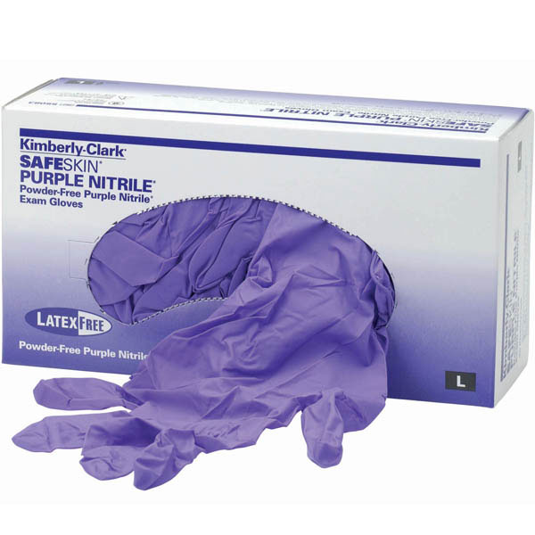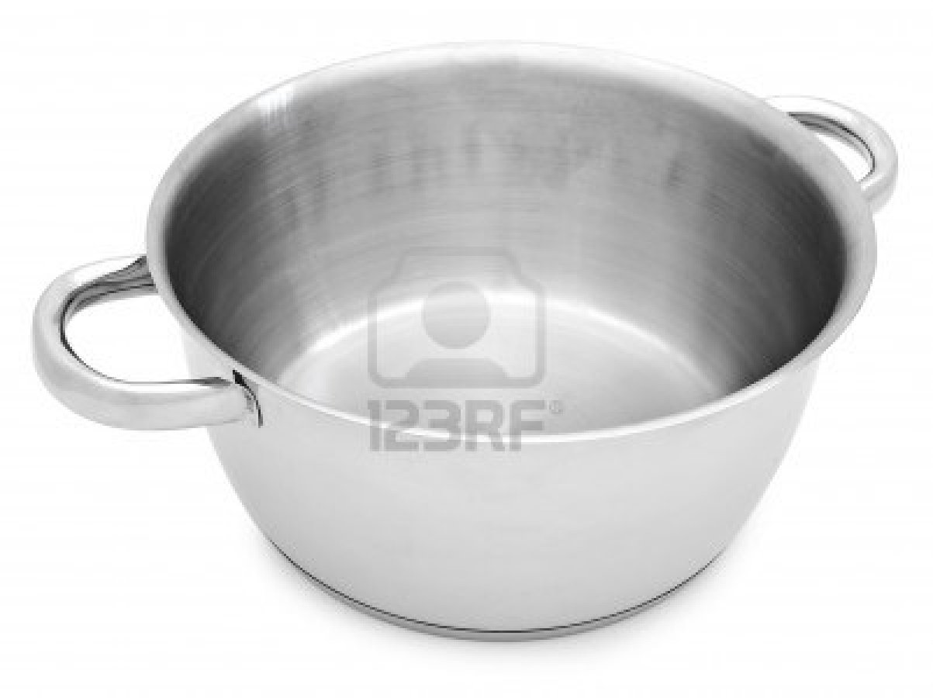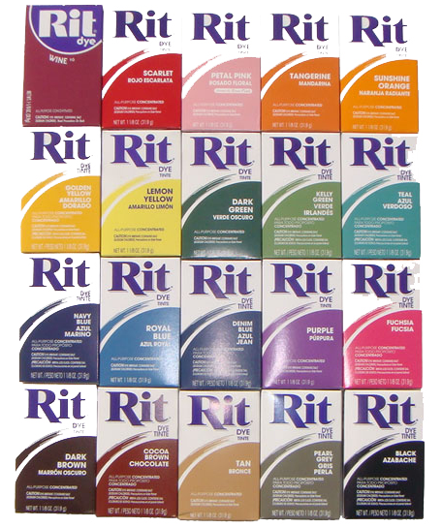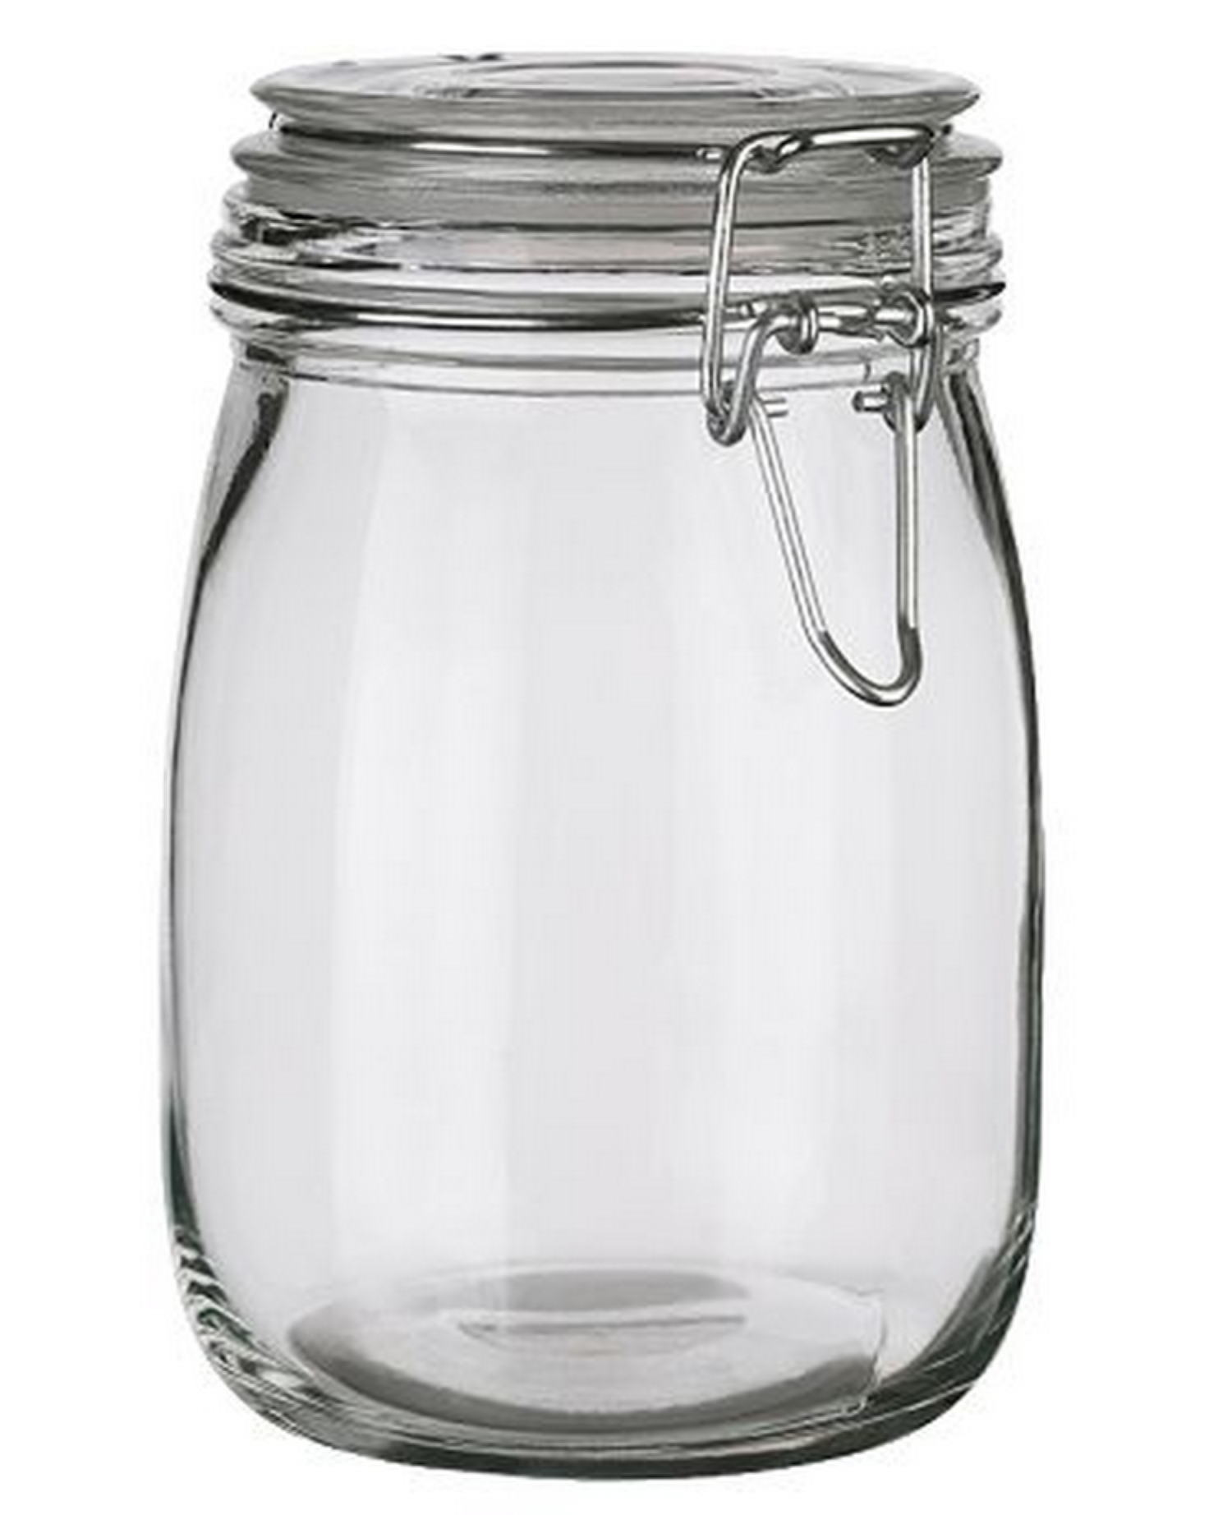

- Boil water and then turn down to simmer
- Add RIT dye
  - This is a mix used was 10grams to 500ml water but you can dilute or concentrate this to suit colour needed
- Turn off heat source
- Submerge part in RIT dye

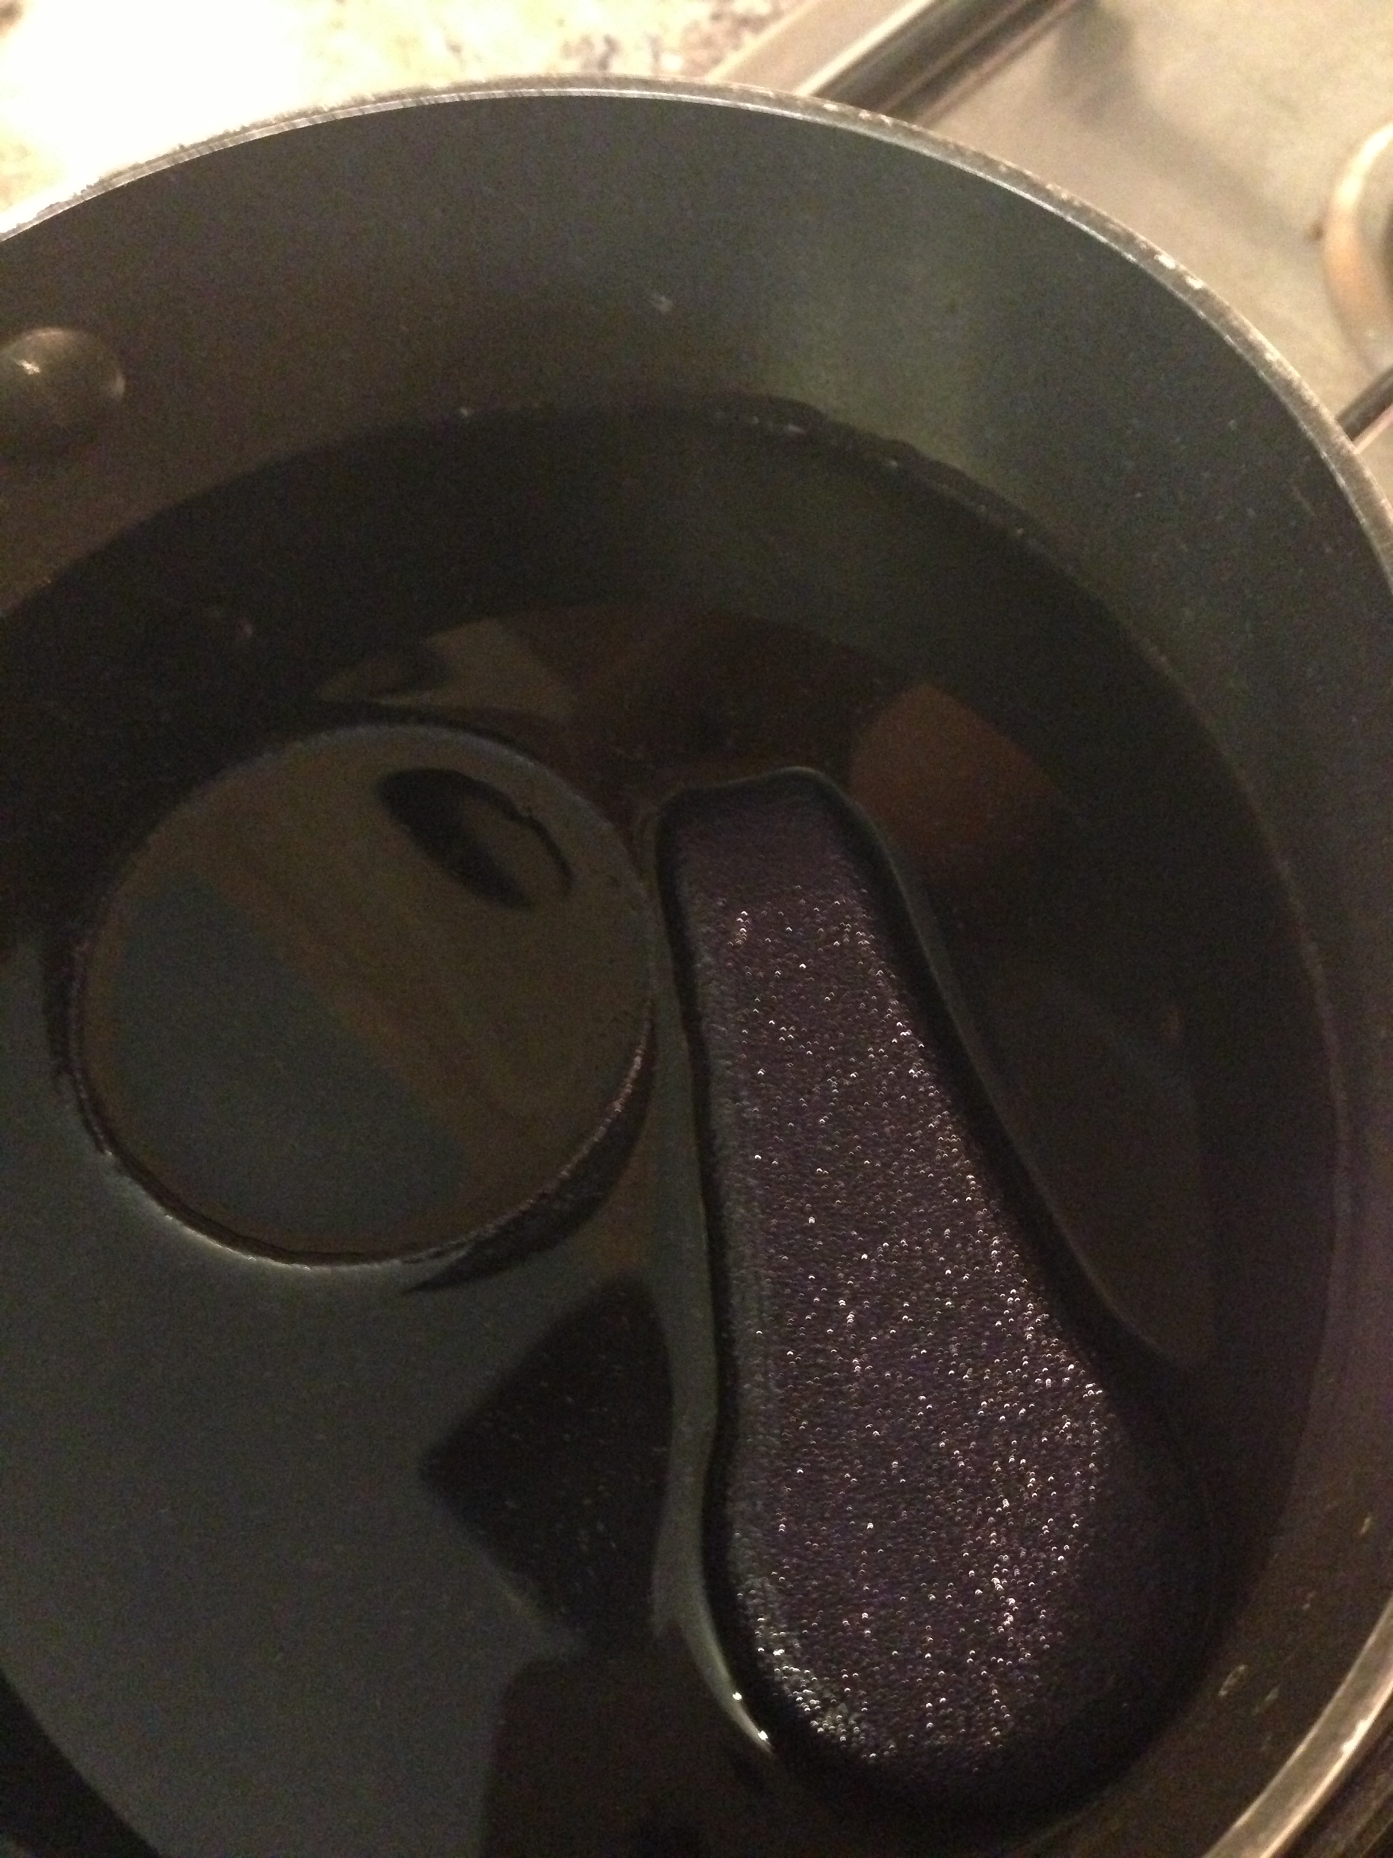
- Leave from between 2-10 minutes depending on how deep you want the colour to be (use your test parts)
- Remove parts and place on kitchen towel allow to cool
- Rinse parts off in cold water
- Allow to dry (these parts were done using Navy Blue ones that look Black were left for 10 minuets +)

Note don’t have your dye too hot as it deforms the parts

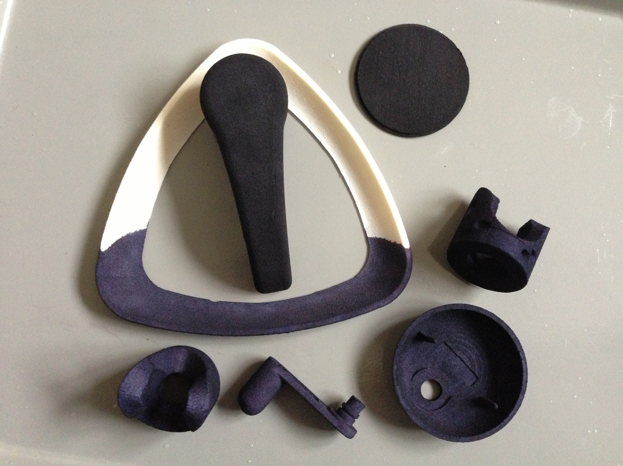

- Store dye in Kilner jar for re use

